MOVIE REVIEW SENTIMENT CLASSIFIER
1. INTRODUCTION / PROBLEM STATEMENT
1.1 Introduction
Movies are an important form of entertainment, and viewers commonly share their opinions through online platforms. These opinions may contain information about the storyline, acting, direction, music, visual effects, and overall quality of a movie.
A movie review is generally written in natural language and may contain positive, negative, or mixed opinions. When thousands of reviews are available, manually reading and understanding every review becomes difficult.
Sentiment Analysis provides an automated solution to this problem. It is a Natural Language Processing technique used to identify the emotional or opinion-based meaning of text.
In this project, sentiment analysis is applied specifically to movie reviews. The system learns patterns from previously labeled movie reviews and uses those patterns to classify new reviews.
For example:
Input:
“The movie was excellent. The acting and story were amazing.”
Output:
Positive Sentiment
Another example:
Input:
“The movie was boring and the story was very weak.”
Output:
Negative Sentiment
Thus, the system provides a quick and automated method for analyzing movie opinions.
1.2 Problem Statement
The number of online movie reviews is continuously increasing. Manually analyzing a large number of reviews requires considerable time and effort. There is therefore a need for an automated system that can process textual movie reviews and determine their sentiment.
The problem addressed by this project is:
To develop a machine-learning-based system that automatically analyzes movie reviews and classifies them as positive or negative.
1.3 Need for the System
The system is useful because:
- Large numbers of reviews can be analyzed automatically.
- Manual analysis requires more time.
- Machine learning can identify patterns in textual data.
- Users can quickly understand the overall opinion expressed in reviews.
- The system can be extended to other types of feedback.
1.4 Scope
The project focuses on binary sentiment classification of movie reviews. The system can be extended in the future to support neutral and mixed sentiments, multiple languages, and advanced deep-learning techniques.

2. LITERATURE SURVEY / EXISTING SYSTEM
2.1 Literature Survey
Sentiment analysis has been widely studied as a Natural Language Processing task. Researchers have developed different techniques for identifying opinions in textual data.
Early sentiment-analysis systems commonly used manually created rules and dictionaries containing positive and negative words. Although these approaches are simple, they have difficulty understanding context.
Machine-learning techniques later became popular because they can learn patterns from labeled datasets. Algorithms such as Naive Bayes, Logistic Regression, Support Vector Machines, and Decision Trees have been applied to text classification.
More advanced systems use deep-learning and transformer-based models to understand complex relationships between words and sentences.
For movie reviews, machine-learning classification generally follows the following process:
Review → Text Preprocessing → Feature Extraction → Model Training → Sentiment Prediction
2.2 Existing System
In a traditional system, users may manually read reviews and decide whether the review expresses a positive or negative opinion.
Some automated systems use simple keyword matching. For example, words such as excellent, amazing, and wonderful may indicate positive sentiment, while words such as bad, boring, and poor may indicate negative sentiment.
2.3 Limitations of Existing System
The existing approaches have several limitations:
- Manual analysis is time-consuming.
- Simple keyword-based methods may not understand context.
- Sarcasm can be difficult to identify.
- Mixed opinions can be incorrectly classified.
- Large datasets require automated processing.
- Different writing styles can affect classification accuracy.
The proposed machine-learning system attempts to overcome these limitations by learning patterns from a labeled dataset.

3. PROPOSED SYSTEM / OBJECTIVES
3.1 Proposed System
The proposed system is a Movie Review Sentiment Classifier that uses Natural Language Processing and machine learning to classify reviews automatically.
The system consists of several stages:
- Dataset collection
- Data preprocessing
- Feature extraction
- Dataset splitting
- Model training
- Model evaluation
- Sentiment prediction
The user provides a movie review through the application. The review is processed using the same preprocessing and feature-extraction pipeline used during training. The trained model then predicts the sentiment.
3.2 Objectives
The main objectives are:
- To develop an automated movie-review sentiment classifier.
- To preprocess textual movie reviews.
- To convert text into numerical features.
- To train a machine-learning classification model.
- To evaluate the performance of the trained model.
- To classify new reviews as positive or negative.
- To provide a simple and understandable user interface.
- To demonstrate the practical application of NLP and machine learning.
3.3 Key Features
The proposed system provides:
- Text-based review input.
- Automatic text preprocessing.
- Feature extraction.
- Machine-learning classification.
- Positive/negative prediction.
- Fast prediction.
- Easy-to-use interface.
- Performance evaluation.

4. SYSTEM REQUIREMENTS
4.1 Hardware Requirements
Component | Minimum Requirement
Processor | Intel Core i3 or equivalent
RAM | 4 GB or above
Storage | 10 GB free space
Display | Standard monitor
Keyboard | Standard keyboard
Mouse | Standard mouse
For better performance, 8 GB or more RAM is recommended when working with large datasets.
4.2 Software Requirements
Software | Purpose
Windows/Linux | Operating System
Python | Programming language
VS Code/Jupyter Notebook | Development environment
Pandas | Data processing
NumPy | Numerical operations
NLTK | Natural Language Processing
Scikit-learn | Machine learning
Matplotlib | Visualization
Seaborn | Data visualization

5. SYSTEM DESIGN
5.1 System Architecture
The overall architecture of the proposed system can be represented as:
5.1 System Architecture
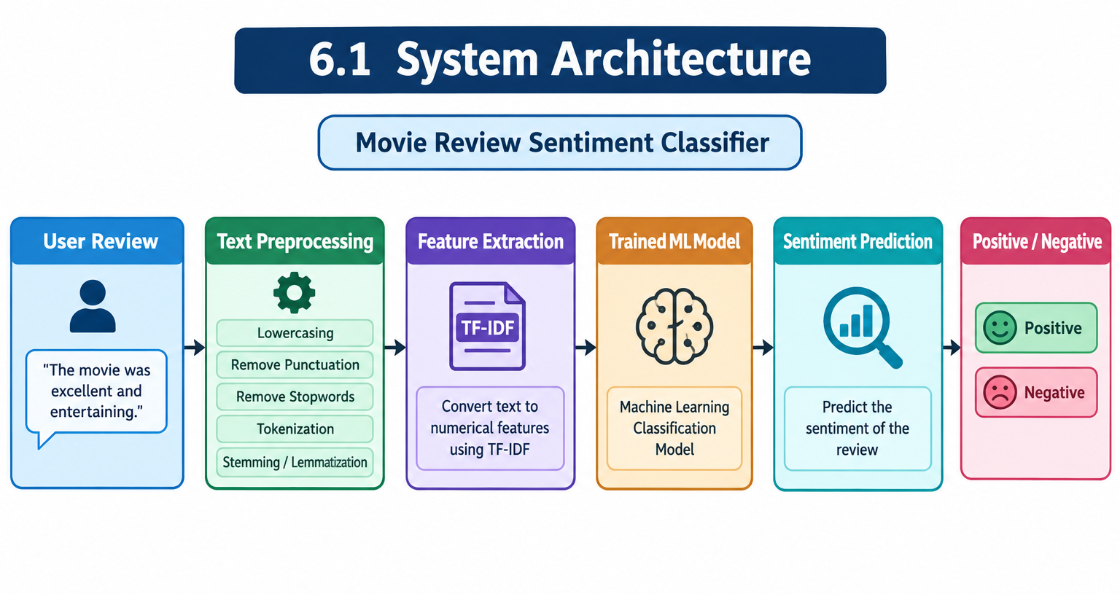
5.2 Flowchart
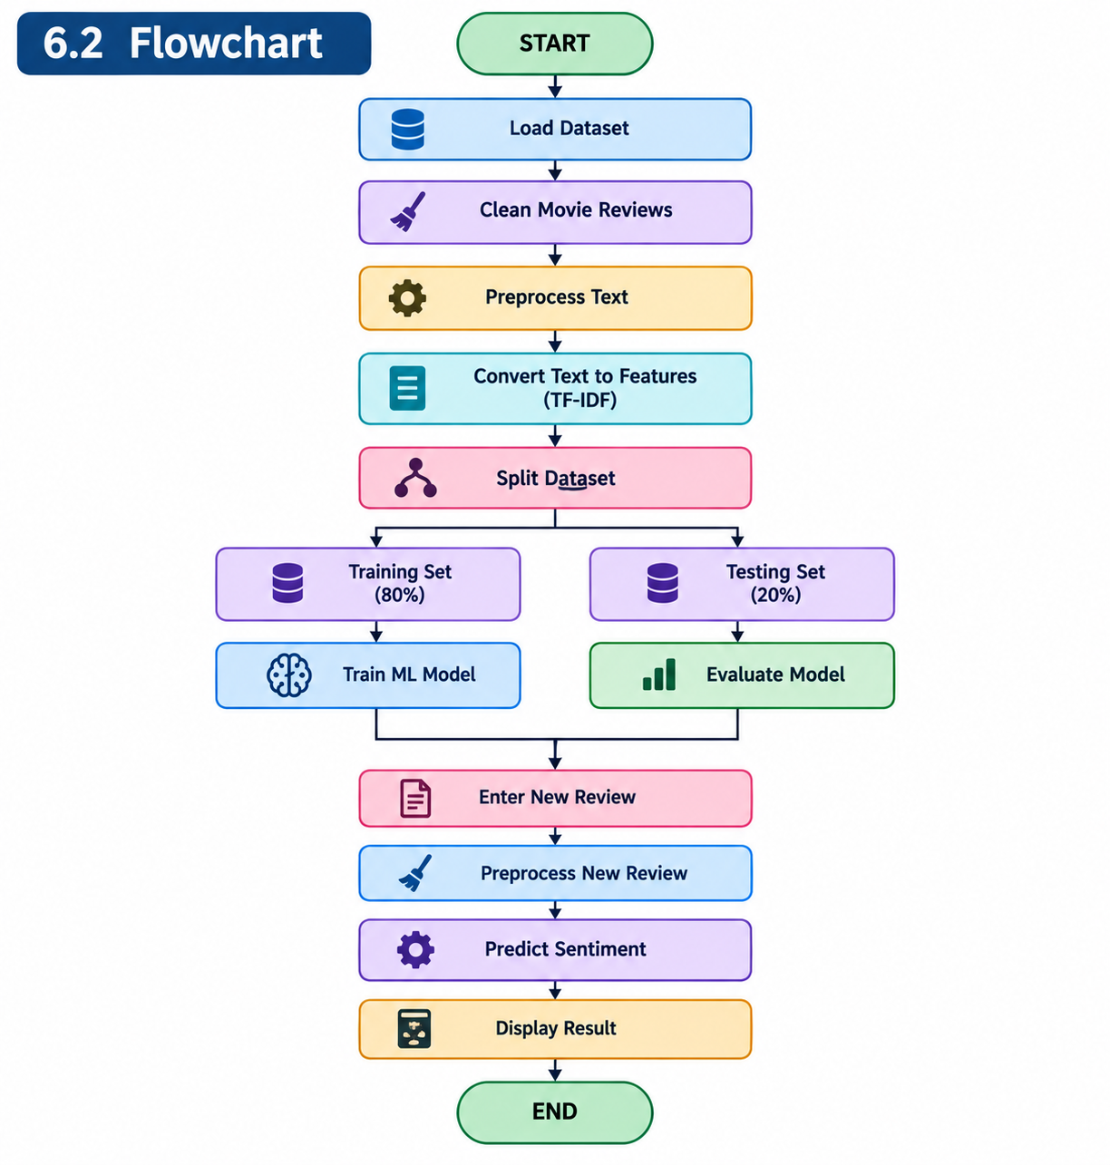
5.3 Data Flow Diagram
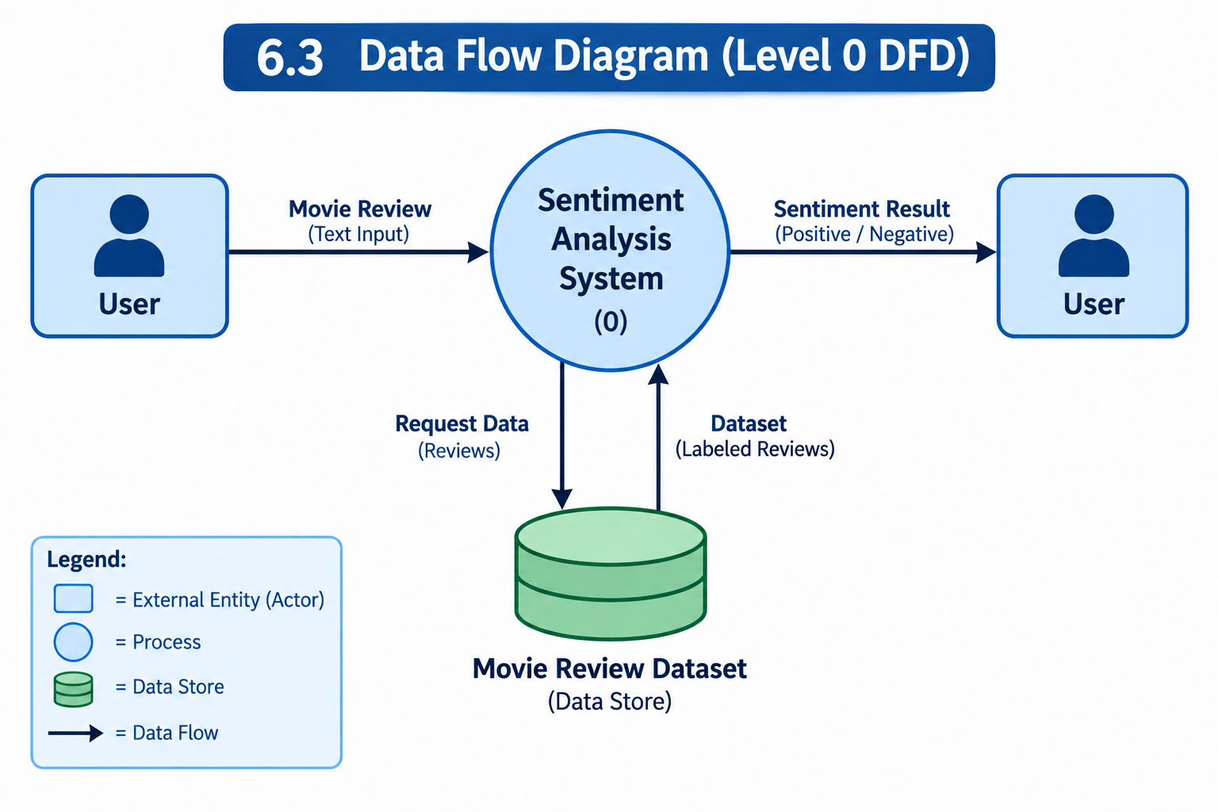
5.4 Use Case Diagram
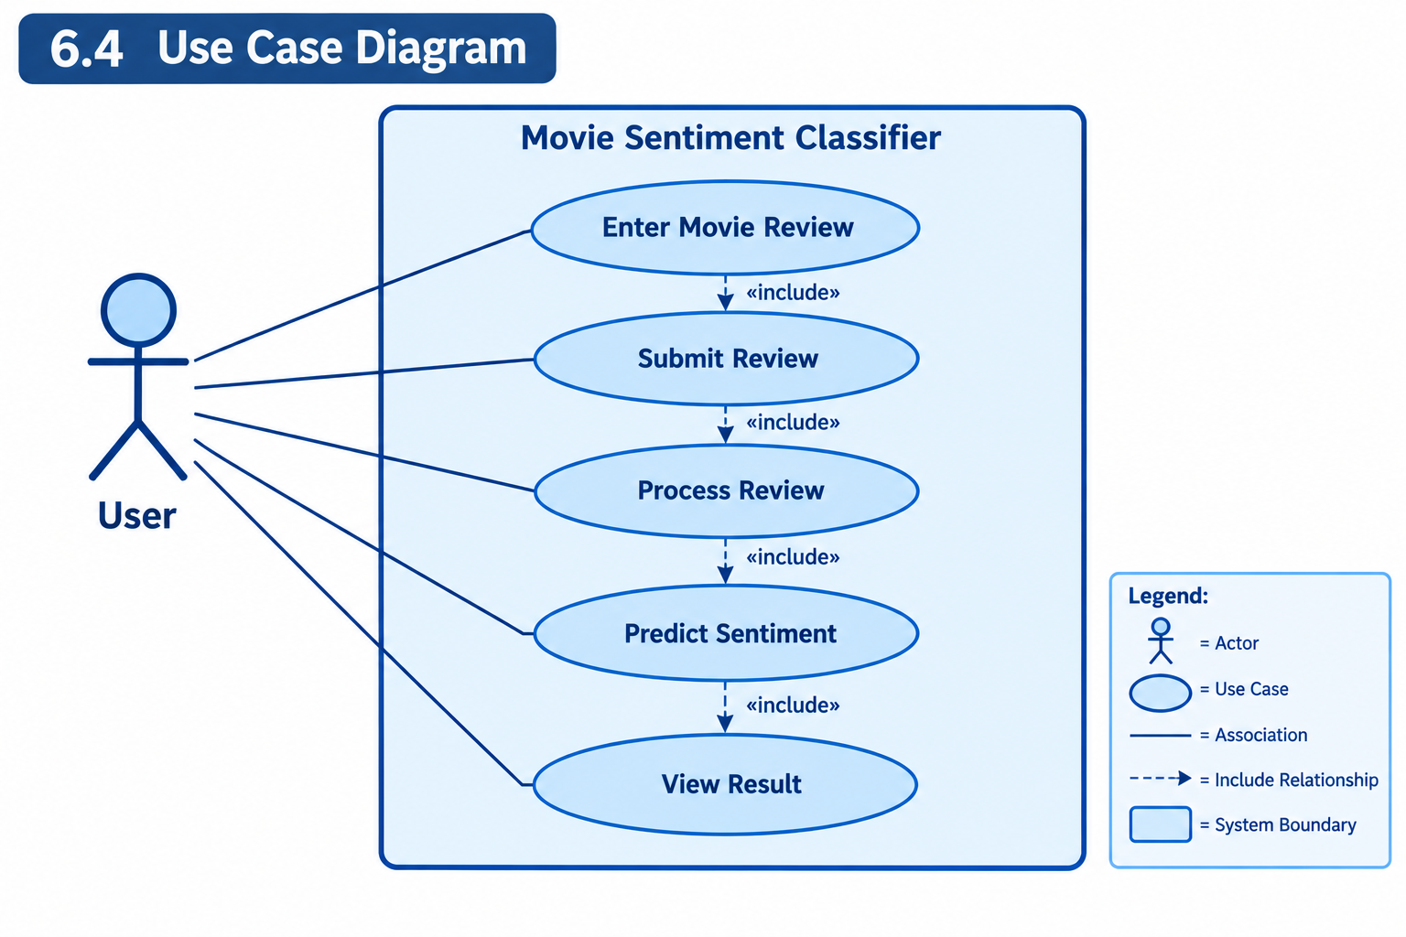

6. MODULES / METHODOLOGY
6.1 Dataset Collection
The first step is to obtain a labeled movie-review dataset. Each review contains textual information and its corresponding sentiment label.
Example:
Review | Sentiment
“Amazing movie with excellent acting.” | Positive
“The movie was boring and disappointing.” | Negative
The dataset is divided into input features and target labels.
6.2 Data Preprocessing
Raw textual data may contain unnecessary characters, symbols, HTML tags, and inconsistent capitalization.
The following preprocessing operations can be performed:
- Convert text to lowercase.
- Remove unnecessary punctuation.
- Remove unwanted characters.
- Remove stopwords.
- Tokenize the text.
- Apply stemming or lemmatization where required.
Example:
Original:
“The Movie was AMAZING!!!”
Processed:
“movie amazing”
6.3 Feature Extraction
Machine-learning algorithms cannot directly process normal text. Therefore, textual reviews must be converted into numerical representations.
TF-IDF (Term Frequency–Inverse Document Frequency) is one suitable technique.
TF-IDF gives importance to words based on their occurrence in a document and their frequency across the complete collection of documents.
The resulting numerical vectors are provided to the machine-learning model.
6.4 Dataset Splitting
The dataset is divided into:
- Training dataset
- Testing dataset
The training data is used to learn patterns, while the testing data is used to evaluate the trained model on unseen reviews.
A common split is 80:20, where 80% is used for training and 20% for testing.
6.5 Model Training
A supervised machine-learning classification algorithm is trained using the processed movie reviews.
Possible algorithms include:
- Logistic Regression
- Naive Bayes
- Support Vector Machine
- Random Forest
For text classification, Logistic Regression or Naive Bayes can provide a simple and effective baseline.
6.6 Sentiment Prediction
After training, the model receives a new movie review.
The review is:
Input → Preprocessed → TF-IDF transformed → Model prediction → Sentiment
The final output is displayed as either:
Positive or Negative
7. IMPLEMENTATION – TECHNOLOGY STACK
7.1 Python
Python is the primary programming language used to develop the system.
7.2 Pandas
Pandas is used for:
- Loading datasets
- Managing tabular data
- Cleaning data
- Selecting columns
- Handling missing values
7.3 NumPy
NumPy provides numerical operations and supports efficient data processing.
7.4 NLTK
NLTK can be used for:
- Tokenization
- Stopword removal
- Stemming
- Text preprocessing
7.5 Scikit-learn
Scikit-learn is used for:
- Train-test splitting
- TF-IDF feature extraction
- Machine-learning algorithms
- Performance evaluation

7.6 Matplotlib and Seaborn
These libraries can be used to visualize:
- Class distribution
- Confusion matrix
- Model performance
- Other project results

8. IMPLEMENTATION – PREPROCESSING AND TRAINING
8.1 Loading the Dataset
The dataset is loaded into Python using Pandas.

import pandas as pd
df = pd.read_csv("movie_reviews.csv")
print(df.head())
8.2 Separating Features and Labels
The review text is used as the input feature and the sentiment is used as the target.
X = df["review"]
y = df["sentiment"]
8.3 Train-Test Split
from sklearn.model_selection import train_test_split

X_train, X_test, y_train, y_test = train_test_split(
X, y, test_size=0.2, random_state=42
)

8.4 TF-IDF Feature Extraction
from sklearn.feature_extraction.text import TfidfVectorizer

vectorizer = TfidfVectorizer()
X_train_tfidf = vectorizer.fit_transform(X_train)
X_test_tfidf = vectorizer.transform(X_test)
8.5 Model Training
Example using Logistic Regression:
from sklearn.linear_model import LogisticRegression

model = LogisticRegression()
model.fit(X_train_tfidf, y_train)
8.6 Prediction
prediction = model.predict(X_test_tfidf)
The predicted values are compared with the actual labels to determine model performance.
8.7 User Review Prediction
For a new review:
review = ["The movie was fantastic and enjoyable"]

review_tfidf = vectorizer.transform(review)

result = model.predict(review_tfidf)

print(result[0])
The output can be displayed as Positive or Negative.

9. TESTING – TEST CASES
Testing is performed to verify that the system produces the expected output for different types of input.
9.1 Functional Testing
Test Case | Input | Expected Result | Status
TC01 | “Excellent movie and great acting.” | Positive | Pass
TC02 | “Very boring and disappointing movie.” | Negative | Pass
TC03 | “Amazing story and wonderful performance.” | Positive | Pass
TC04 | “The movie was terrible.” | Negative | Pass
TC05 | Empty input | Validation message | Pass
TC06 | Long review | Sentiment prediction | Pass
TC07 | Short review | Sentiment prediction | Pass
9.2 Performance Testing
The trained model is evaluated using unseen testing data. The following metrics can be used:
Accuracy
Accuracy represents the percentage of correctly classified reviews.
Precision
Precision measures how many reviews predicted as a particular class were actually members of that class.
Recall
Recall measures how many actual reviews belonging to a class were correctly identified.
F1-Score
F1-score combines precision and recall into a single performance measure.
9.3 Confusion Matrix
A confusion matrix can be used to show:
- True Positive
- True Negative
- False Positive
- False Negative
It provides a detailed understanding of classification performance.

10. RESULTS AND DISCUSSION
The Movie Review Sentiment Classifier successfully demonstrates the application of machine learning and Natural Language Processing to movie-review analysis.
After preprocessing and feature extraction, the reviews are converted into numerical features and supplied to the classification model.
The model's performance should be reported using the actual values obtained during implementation.
10.1 Performance Table
Metric | Result
Accuracy | XX%
Precision | XX%
Recall | XX%
F1-Score | XX%
The XX% values should be replaced with the actual results generated by the project.
10.2 Discussion
The performance of the classifier depends on several factors, including:
- Quality of the dataset
- Number of training samples
- Text preprocessing
- Feature-extraction technique
- Machine-learning algorithm
- Distribution of positive and negative reviews
A properly prepared dataset and suitable feature-extraction method can significantly improve classification performance.
The system is effective for straightforward positive and negative reviews. However, complex language, sarcasm, mixed opinions, and context-dependent statements may still produce incorrect predictions.
10.3 Example Predictions
Review | Predicted Sentiment
“The movie was fantastic and entertaining.” | Positive
“The story was weak and the movie was boring.” | Negative
“Excellent acting and beautiful visuals.” | Positive
“I did not enjoy this movie at all.” | Negative

11. ADVANTAGES, LIMITATIONS AND FUTURE SCOPE
11.1 Advantages
The main advantages of the system are:
- Automatic Analysis
Reviews can be analyzed without manual classification.
- Time Saving
Large numbers of reviews can be processed quickly.
- Easy to Use
Users only need to enter a movie review.
- Machine-Learning Based
The model learns sentiment patterns from training data.
- Scalable
The system can be trained using larger datasets.
- Extensible
The same approach can be applied to product reviews, customer feedback, and social-media comments.

11.2 Limitations
The system has some limitations:
- Sarcasm may be difficult to identify.
- Mixed sentiments may be incorrectly classified.
- Prediction quality depends on the training dataset.
- Spelling errors can affect classification.
- Context-dependent sentences may be misunderstood.
- Basic models may not understand complex language relationships.
11.3 Future Scope
The project can be improved in several ways.
Multiclass Sentiment
Instead of only positive and negative classes, the system can support:
- Positive
- Negative
- Neutral
Multilingual Support
The system can be extended to analyze reviews written in Indian languages such as Kannada, Hindi, Marathi, and others.
Deep Learning
Advanced models such as LSTM, GRU, BERT, or other transformer-based architectures can be used to improve language understanding.
Aspect-Based Sentiment Analysis
The system can identify sentiment related to individual aspects such as:
- Acting
- Story
- Music
- Direction
- Visual effects
Real-Time Analysis
The classifier could be connected to online review platforms and perform real-time analysis.
Recommendation System
Sentiment analysis could be combined with movie ratings to recommend movies to users.

12. CONCLUSION
The Movie Review Sentiment Classifier demonstrates how Natural Language Processing and machine learning can be used to automatically analyze opinions expressed in movie reviews.
The project begins with the collection of labeled movie-review data. The textual data is then cleaned and preprocessed to remove unnecessary information. Feature extraction techniques such as TF-IDF convert the processed reviews into numerical representations. A machine-learning classification model is trained using these features and evaluated using appropriate performance metrics.
The completed system accepts a new movie review and predicts whether the review expresses a positive or negative sentiment. This reduces the need for manual analysis and provides a simple method for understanding large amounts of textual feedback.
The project also provides practical knowledge about Python programming, data preprocessing, Natural Language Processing, feature extraction, machine-learning model training, evaluation, and user-interface development.
Although the current system has limitations when dealing with sarcasm, mixed opinions, and complex language, it provides a useful foundation for sentiment-analysis applications. Future improvements such as deep learning, multilingual analysis, neutral sentiment classification, aspect-based sentiment analysis, and real-time processing can make the system more powerful.
Overall, the project successfully demonstrates the practical application of Artificial Intelligence, Machine Learning, and Natural Language Processing to a real-world problem.

13. REFERENCES / BIBLIOGRAPHY
- Python Documentation, Python Software Foundation.
- Scikit-learn Documentation, Machine Learning in Python.
- NLTK Documentation, Natural Language Toolkit.
- Pandas Documentation, Python Data Analysis Library.
- NumPy Documentation, Numerical Computing with Python.
- Matplotlib Documentation, Python Visualization Library.
- Jurafsky, D. and Martin, J. H., Speech and Language Processing, Natural Language Processing reference material.
- Research literature related to Natural Language Processing and Sentiment Analysis.
- Movie review sentiment-analysis dataset used for model training and testing.
- Relevant academic articles and online technical documentation related to text classification, TF-IDF, and machine learning.

